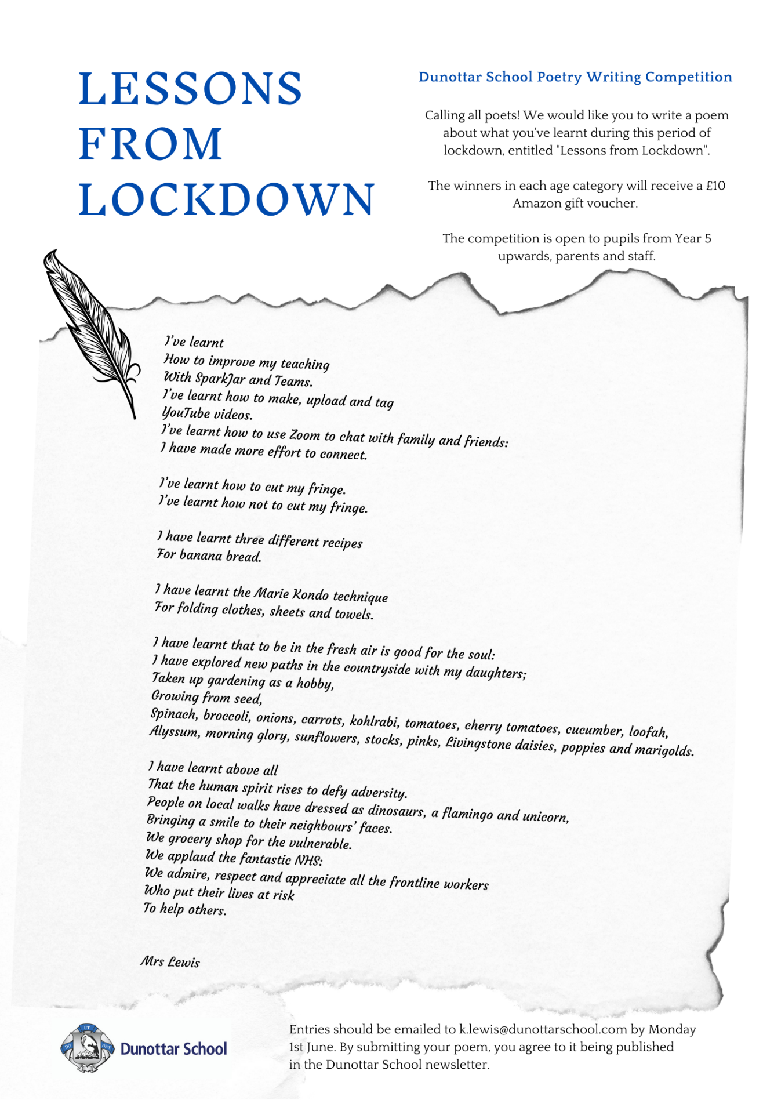

Dunottar School Poetry Writing Competition
Lessons from Lockdown

Name:

School:
Contact email (if not Dunottar pupil or staff)

Please tick the category that applies to you | Year 5 | Years 7 & 8 | Years 9, 10 & 11 | Sixth Form | Parents | Staff

Please enter your poem below.

Entries should be emailed to k.lewis@dunottarschool.com by Monday 1st June. By submitting your poem, you agree to it being published in the Dunottar School newsletter.

